Q1.

ANSWER-1.

TO CALCULATE AVG INTEREST RATE FOR EACH LOAN GRADE:



TO CALCULATE AVG LOAN AMOUNT FOR EACH LOAN GRADE:



TO CALCULATE DEFAULT RATE PER LOAN GRADE:



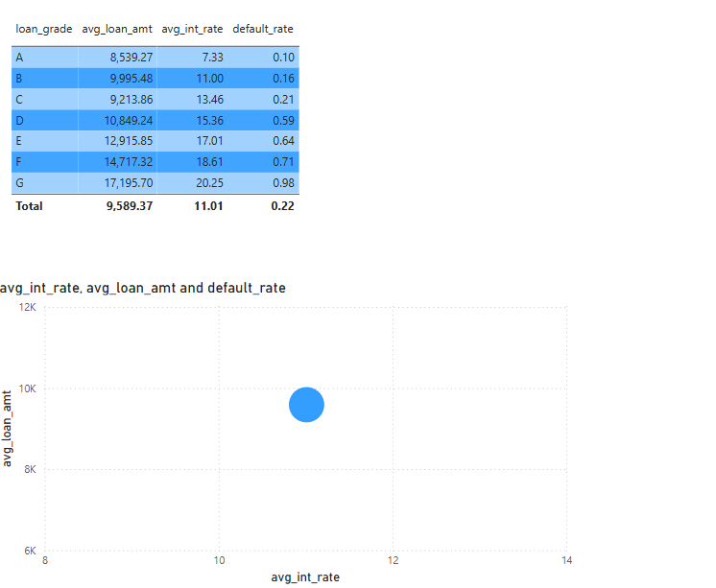

EXPLANATION:

• Create a table visual to display loan_grade, AvgLoanAmount, AvgInterestRate, and DefaultRate.

• Use a scatter plot to visualize the correlation between average loan amount, interest rate, and default rate.

• Generally, lower loan grades (e.g., C, D, E) might have higher interest rates and default rates.

Q2.

ANSWER-2.

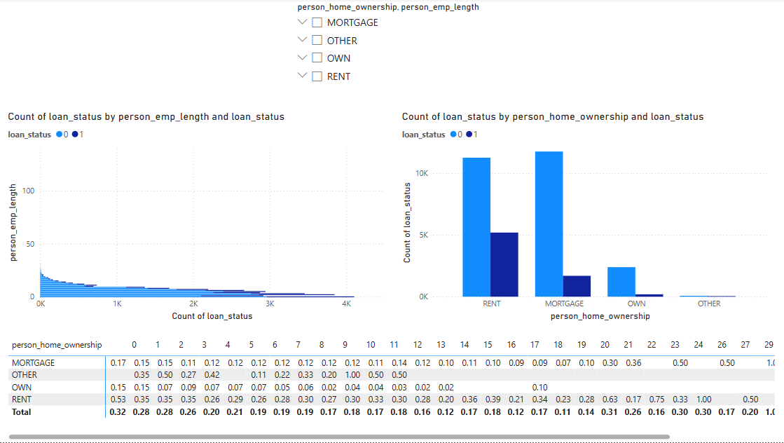

EXPLANATION:

• Use a stacked bar chart:

• X-axis: person_emp_length

• Y-axis: Count of loan_status

• Color: Loan status (default vs. non-default)

• Use a clustered column chart:

• X-axis: person_home_ownership

• Y-axis: Count of loan_status

• Color: Loan status

• Identify which combinations (renters with short employment length) show the highest default rates.

Q3.

ANSWER-3. 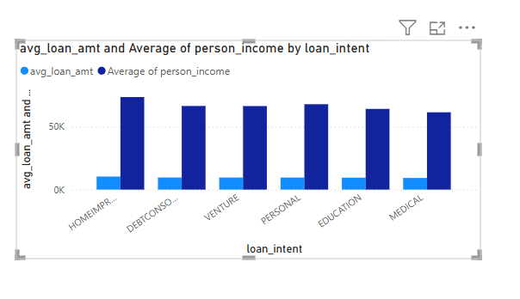



EXPLANATION:

• Create a clustered column chart:

• X-axis: loan_intent

• Y-axis:

• AvgIncome = AVERAGE(CreditData[person_income])

•AvgLoanAmount = AVERAGE(CreditData[loan_amnt])

• Calculate Loan-to-Income Ratio:

LoanToIncomeRatio = DIVIDE(AVERAGE(CreditData[loan_amnt]), AVERAGE(CreditData[person_income]))

• Highlight which loan intent category has the highest loan-to-income ratio.

Q4.

ANSWER-4.

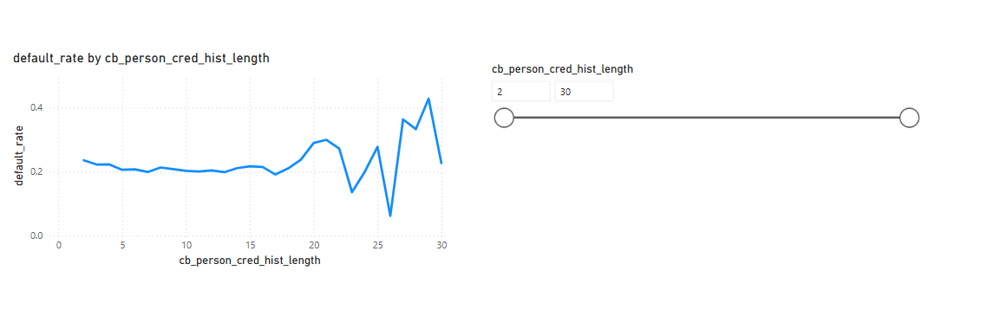

EXPLANATION:

• Use a line chart:

• X-axis: cb_person_cred_hist_length

• Y-axis: Default Rate (from Q1)

• Add a slicer to filter by different credit history lengths.

Q5.

ANSWER-5.

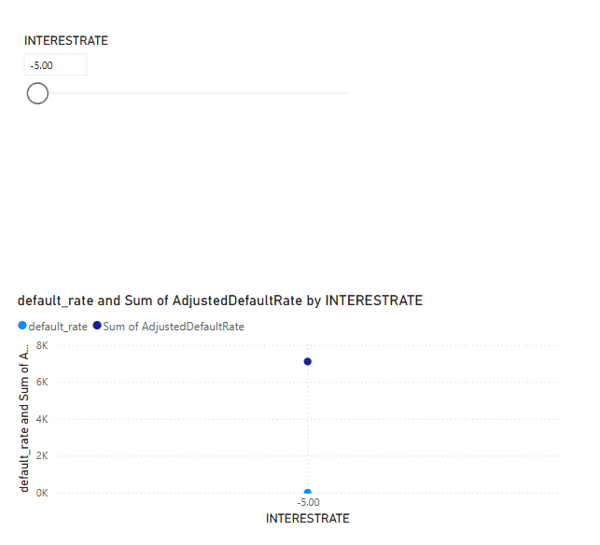

EXPLANATION:

1. Create a What-if Parameter:

• Go to Modeling > New Parameter.

• Set Name: InterestRateChange, Range: -5% to +5%, Increment: 0.5%.

2. Modify Interest Rate Impact on Default Probability:

AdjustedDefaultRate = DefaultRate * (1 + [InterestRateChange])

3. Use a line chart to show how default rates change with different interest rates.

Q6.

ANSWER-6.

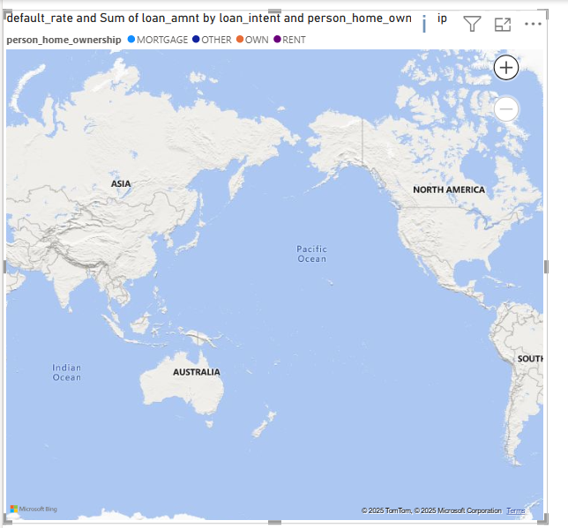

EXPLANATION:

• Use filled maps or bubble maps to visualize loan distribution.

• Compare default rates across different regions.

Q7.

ANSWER-7.

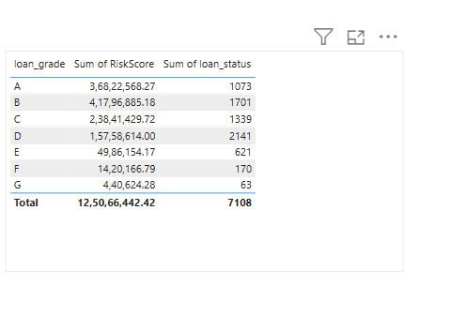

EXPLANATION:

-DEFINE THE RISK SCORE:

RiskScore =

(CreditData[loan_amnt] * 0.4) +

(CreditData[loan_percent_income] * 0.3) +

(IF(CreditData[cb_person_default_on_file] = "Y", 10, 0)) +

(10 - CreditData[person_emp_length]) * 0.2

-THEN Create a table showing risk scores by loan_grade and loan_status.

Q8.

ANSWER-8.

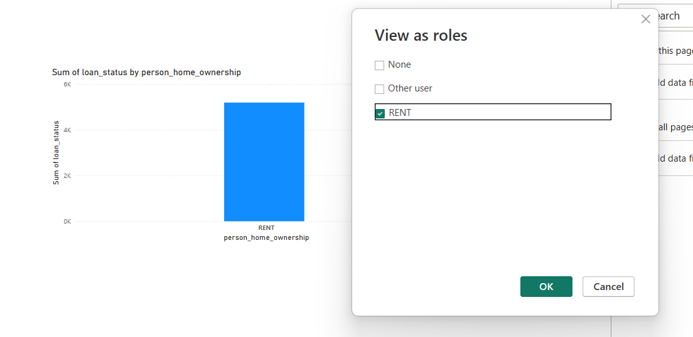

EXPLANATION:

Go to Modeling > Manage Roles > Create New Role

Assign users their respective regions in Power BI Service.

Q9.

ANSWER-9.

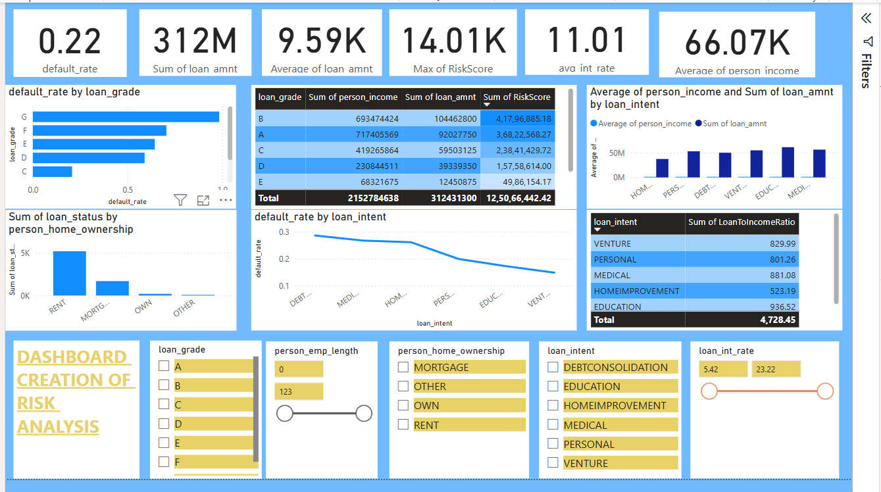

EXPLANATION:

• Use consistent color themes (e.g., green for safe, red for risky)

• Group visuals by topic with headings like “Borrower Risk Analysis”

• Keep KPIs at the top for quick understanding

• Use tooltips to add hidden context to visuals

How to Publish:

1. Click File > Publish > To Power BI Service

2. Choose or create a Workspace

3. Once uploaded, open the report online

4. Create a Dashboard (optional) by pinning visuals

5. Use Share to send it to stakeholders (requires Power BI Pro)

**VEDIO EXPLANATION LINK FOR THE ABOVE QUESTIONS:**

<https://youtube.com/watch?v=LvucapSere4&feature=shared>